This research paper is tied to Attribution theory. Specifically, the researchers are interested in exploring causal reasoning patterns people have for positive or negative performance in cognitive processes. The research question they had in mind was “When a person performs a task, do they attribute the reason of their success or failure depending on the outcome?”

The researchers designed an experiment for MBA students who were asked to perform a cognitive task. Without their knowledge, they were randomly assigned to either poor performers or good performers. Then they were asked to evaluate five internal and external outcome variables. The researchers are interested in knowing if the students will attribute these five variables to the group they were assigned to. The theory is: If the outcome was successful, then the cause of success was attributed internally to them. And if the outcome was not successful, then the cause of failure was attributed to something external and not to them. Therefore, in theory there should be a difference in the evaluations, but it is not clear for this experiment which variables will be more significant.

This is an experiment set to find differences in means having multiple dependent variables of interest. It is also used to find differences among two groups. Therefore, I would recommend using a 1-Way MANOVA. There are multiple assumptions for MANOVA which were satisfied. First, there should be “Random Sampling” which means that each data point has an equal chance of being in either group. This was ensured by having each student assigned randomly to either good performance or poor performance group. Second, the dependent variables should satisfy the multivariate normality distribution assumption. In formal terms, the variables should have the following distribution:

Multivariate (MV) normal distribution

[EFFORT,UND,QUALITY,LUCK,DIFF] ~N5(**μ**,**∑**)

Where **μ** is a vector of 5 rows of means, each row is a mean for each corresponding variable and **∑** is a variance covariance matrix 5X5, each row has the variance of the corresponding variable and the covariance with the other four variables. The dependent variables must have MV normality which assumes univariate normality for each dependent variable, bivariate normality for each pair of dependent variables, and univariate normality for any linear combination of the dependent variables. Also, the variance covariance matrix should be same for each of the two groups. These following figures show the histogram for each dependent variable to check for univariate normality. The histograms in the appendix show that the dependent variables are not perfectly normal, but they roughly follow a normal distribution. This satisfies the univariate normality.

The next step for the analysis was to check the omnibus test using four different tests (Wilk’s Lambda, Pillai’s Trace, Hotelling-Lawley Trace, Roy’s Greatest Root in the appendix). All four tests have a p-value of <.0001. This means that there is a difference between the mean vectors, but we need to examine the different variables on a univariate level to determine which ones have significant difference, and what specific group has a bigger mean. When looking at the univariate ANOVA results. We found that only the amount effort expended, and the quality of the computer model used to have significant differences in means. From Bonferroni’s test on the mean differences of effort, the mean of the group with good performance (4.9) was significantly higher than the group with poor performance (3.8). Bonferroni’s test on the mean differences of quality has shown a significant difference in the means of the two groups with the group of poor performance having a mean of (4.3) and the group of good performance having a mean of (3.7).

**Appendix**

The following histograms show each variable by its corresponding group.

Variables: Amount of effort expended, how well they understood the task, quality of the computer model used, level of good/bad luck, difficulty of the task itself

Level 1: Poor Performance

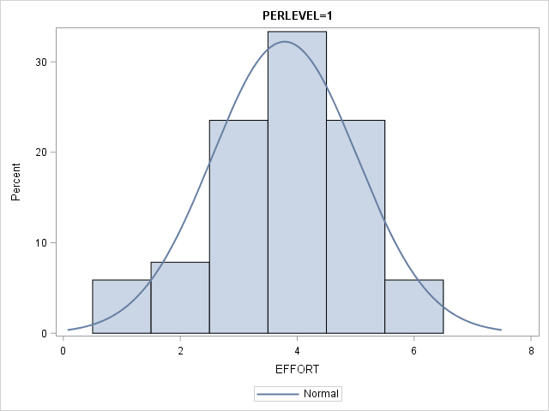 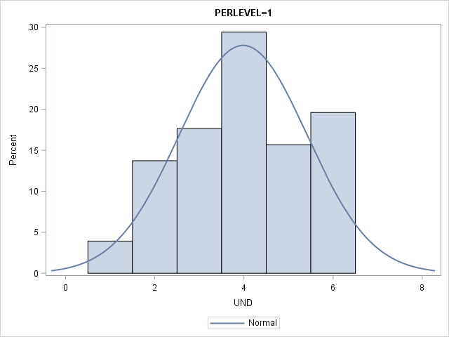 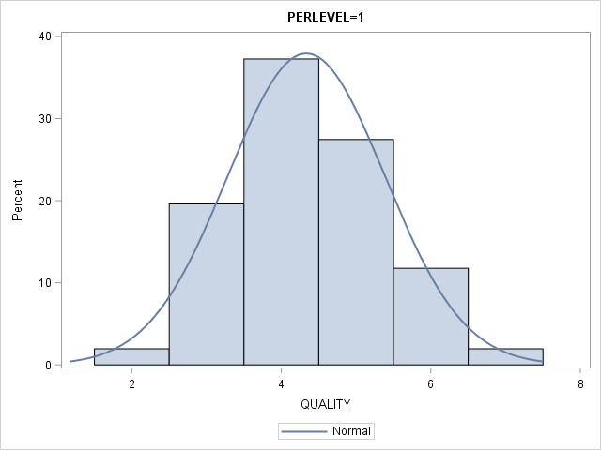 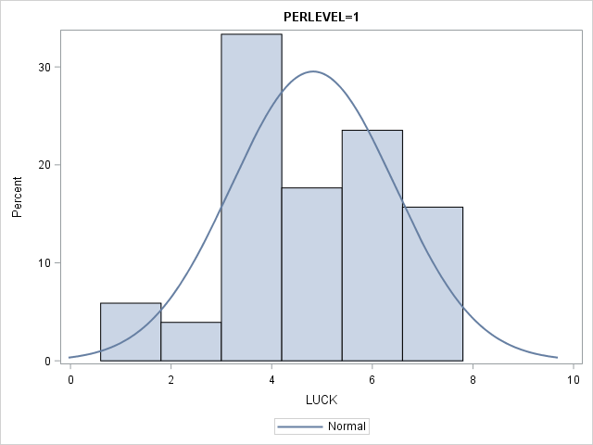 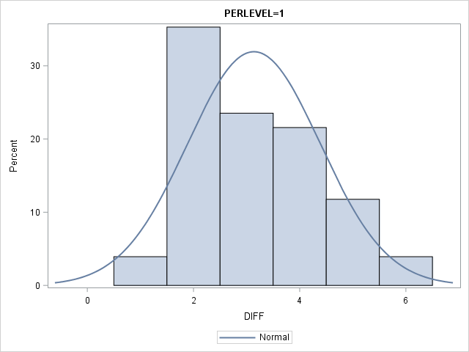

Level 2: Good Performance

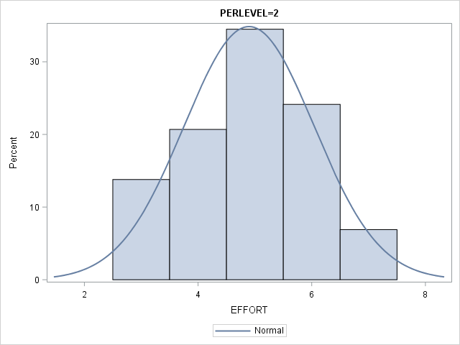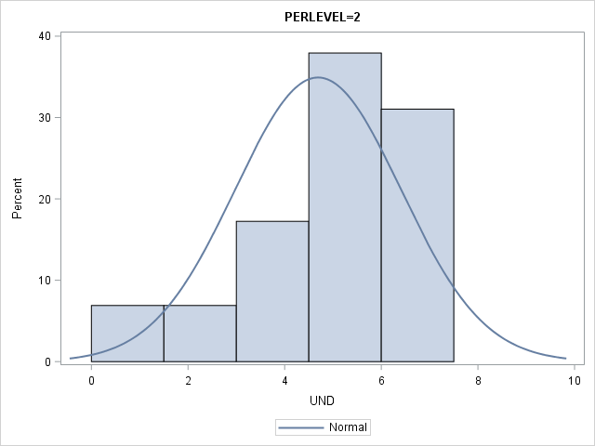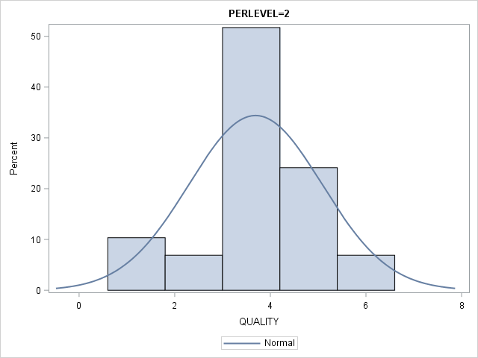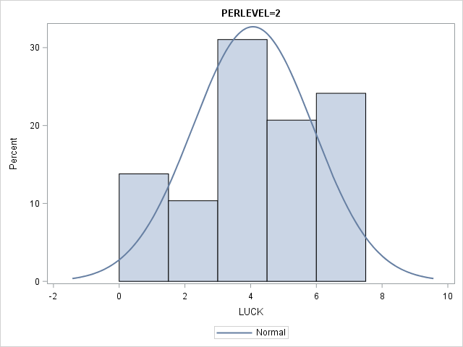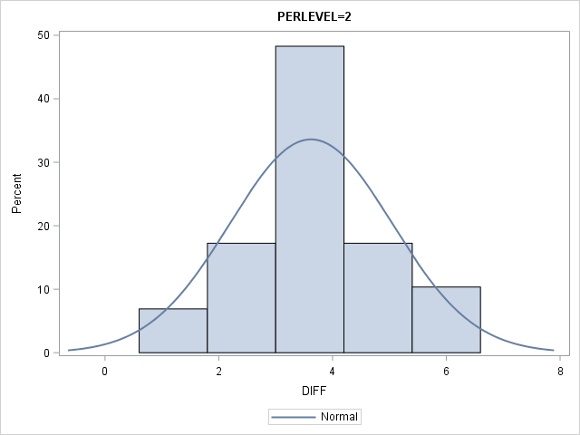

Omnibus Test Results

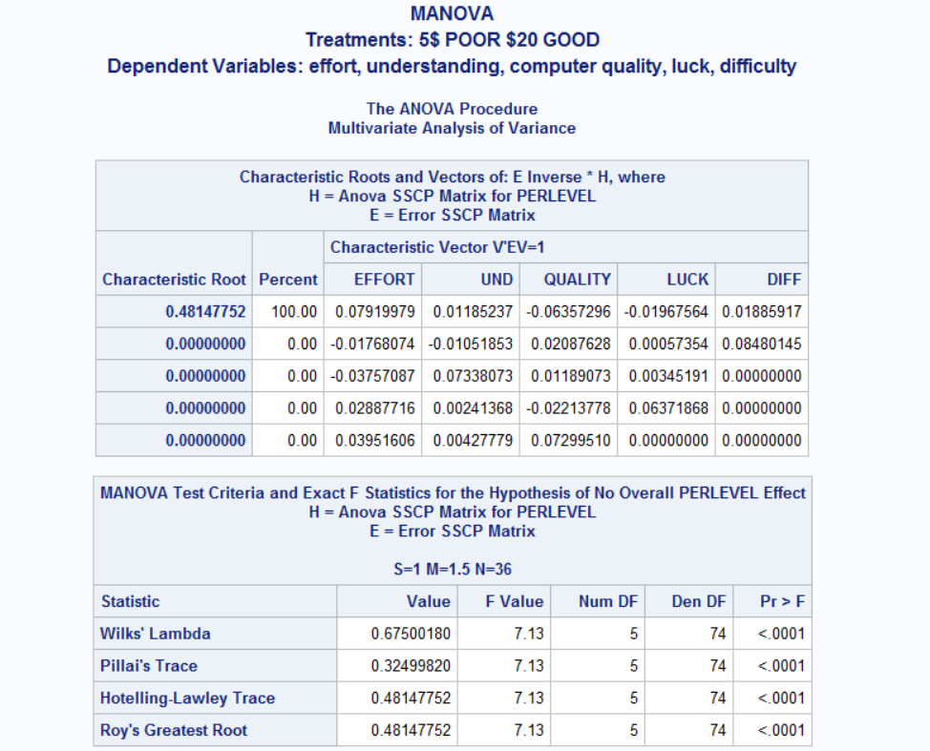

Bonferroni’s test for EFFORT and QUALITY

